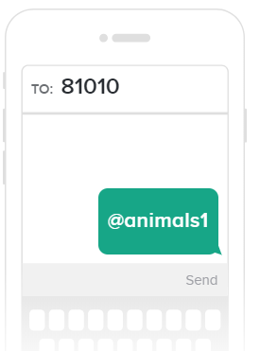
Facilitators: Crumpton, Evans, Pruitt, Vayon
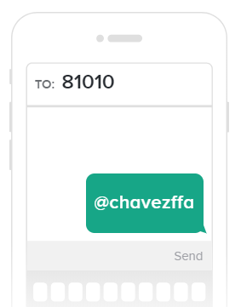
Please Sign In!

- Upcoming dates

  - August 17 Cattle Show
  - August 26 first day of school
  - September 6- Broiler Pick Up
  - September 19- First FFA Meeting
  - October 18 Livestock Show and Auction
  - October 19 Livestock Show Clean Up
  - November 4th District LDE- Humble
  - November 30th Area LDE- Cypress

- FFA Dues
- Parent Dues
- Handbook
- Member Meeting Attendance
- Contact Sheet- https://tinyurl.com/y4wsyctv
- School Show and Auction October 18 Show 2pm- Auction 7 pm
- Non- Animal Projects
- School Show Clean Up Saturday 10 am
- Trash Duty
- Questions?
BREAK OUTS WITH SPECIES ADVISOR
Crumpton Facilities | Vayon- Cattle& Pig | Pruitt- Rabbit & Chicken | Evans- Lamb &Goats
 | Upcoming Shows  Moving Scales  Work Days  Pig Weigh In | Aug 30th – Deadline Picture/meeting to look at pen  Sept 6th – Pick up date  Feed  Feeding Schedule  Supplies List  Rabbits:  Communicate individual plans  Early September – Pick up rabbits  Supply List  Remaining $ - due one week before pick up | LG Pow Wow Start 1st Week  Work Days  Weigh in  Shaving  Majors?

