Facilitators: Crumpton, Evans, Pruitt, Vayon
Please Sign In
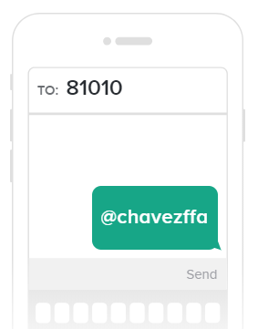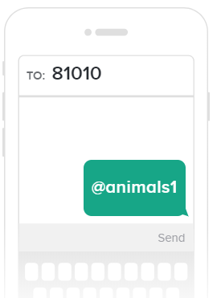
Parents And Students: Please Join Our Remind Classes To Receive Regular Updates On Chapter Activities
Parents- Crumpton | Cattle/ Pigs- Vayon | Lambs/ Goats Evans | Poultry / Rabbits Pruitt

