Facilitators: Crumpton, Evans, Pruitt, Vayon
Please Sign In!
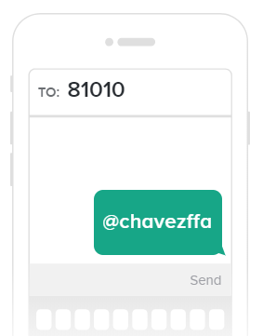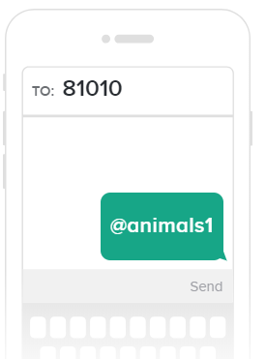
Parents and Students: Please Join Our Remind Classes to Receive Regular Updates on Chapter Activities

- Upcoming dates
  - June 17- Convention Meeting 6:30 pm Vayon room
  - June 19- Fishing trip
  - June 19-23 West Texas Trip
  - June 24⁻ Steer Validation
  - June 25- 26 District/ Chapter Officer Camp
  - July 15-19- Texas State FFA Convention
  - July 10,11,&24- Work Days
  - September 6- Broiler Pick Up

- FFA Dues
- Parent Dues
- Handbook
- Contact Sheet- https://tinyurl.com/y4wsyctv
- Grades
- Convention
- Trash Schedule
- Harris County Fair Survey- https://www.surveymonkey.com/r/HARRISFAIRINFO
- House Keeping in 5005
- School Show and Auction October 18 Show 2pm- Auction 7 pm
- School Show Clean Up Saturday 10 am
- Questions?
BREAK OUTS WITH SPECIES ADVISOR

