Facilitators: Crumpton, Evans, Pruitt, Vayon
Please Sign In!
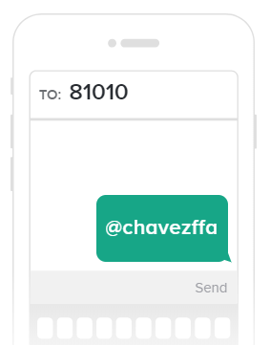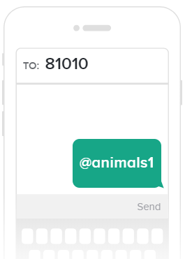
Parents and Students: Please Join Our Remind Classes to Receive Regular Updates on Chapter Activities
- Introductions
Belt Buckle Committee : Elisa Sepulvelda and Bianca Enriquez c/o 2017
- Student Expectations:

Feeding Twice a Day
Integrity- Doing the right thing when no one else is around.
Demerits- Camera Checks Happening Soon- If you receive a Demerit due to previously discussed infractions you will not have the opportunity to work it off.
Calling us when contact info changes
Attend All Chapter FFA Meetings (Third Thursday Each Month Beginning in September)
Be a member in good standing- See Handbook for definition
- Radio
- Speeding
- Parent Dues
- Belt Buckle
- Ads
- Last Chance Belt Buckle and Ad
- L/G Meetings during Lunches- August 29th first meeting
- Cattle: Validation Money- Registration Papers- Neuman Classic Form and Fee
- Poultry: Pick Up date Friday September 21st- Rabbits Last week of September- Order Feed 2 weeks in advance from Gulf Tex Feed.

CHAVEZ FFA SHOW AND AUCTION: NOVEMBER 2ND AND 3RD

