Facilitators: Crumpton, Evans, Pruitt, Vayon
Please Sign In!
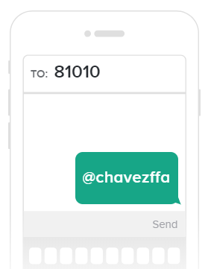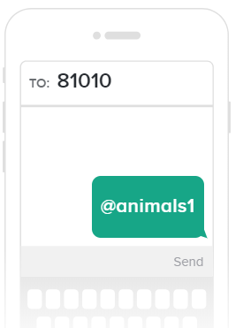
SCHOOL SHOW PROJECTS
Parents and Students: Please Join Our Remind Classes to Receive Regular Updates on Chapter Activities
- Entries- Art, Ag Mech, Culinary, Horticulture
https://preview.tinyurl.com/chavezagmech
- School Show Check Out- November 12th Everything cleaned out of pen
- Parent Shift Sign Up
- Eligibility Check List- Turn into Species Teacher

- Major Animal Entry Money and Forms- Ms. Vayon
- Major Animals- Showing at Houston Livestock Show and Rodeo
  - L/G March 5-7
  - Broilers March 7
Major Animal Projects
  - Breeding Rabbits 9-10
  - Heifers 5-8
- Lamb and Goat Selection October 24- 6:00 pm
- Heifer Validation October 25- Noon
- Lambs and Goat Validation October 29 – Leave Campus 2:20
- Quality Counts- MANDATORY
- Trash Duty- 2 Cans Front and Back – Folding Feed Sacks
- Manure Pile and Dumping
- Community Service Ops- December

CHAVEZ FFA SHOW AND AUCTION: NOVEMBER 2ND AND 3RD

