Facilitators: Crumpton, Evans, Pruitt, Vayon
Please Sign In!
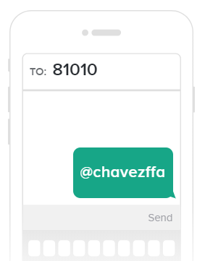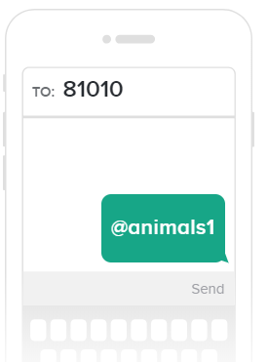
Parents and Students: Please Join Our Remind Classes to Receive Regular Updates on Chapter Activities

- Major Entry Handbook Signature Page Due
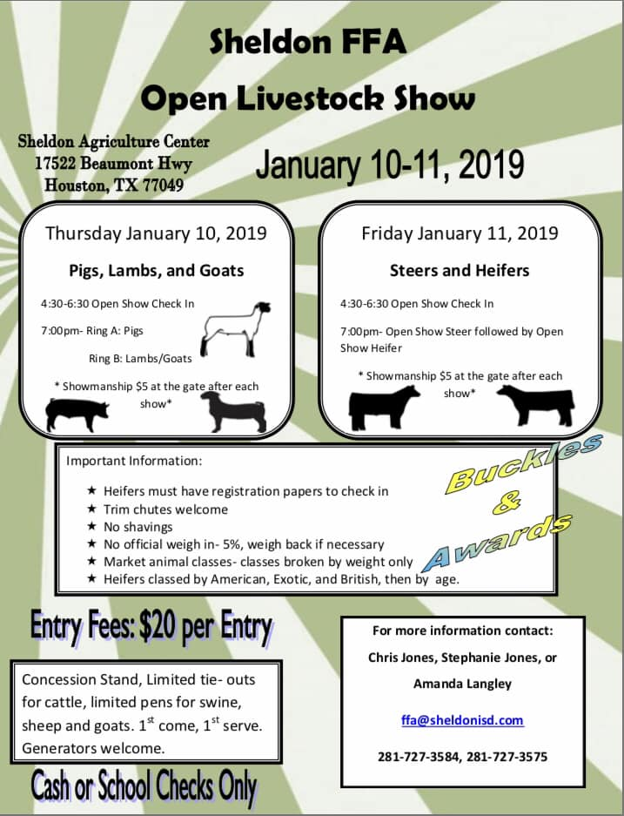
- Expectations of Major Show Exhibitors
- Expectations of Parents
- Sheldon Show
- Other Prospect Shows
- FFA & Parent Dues- New Rabbit Kids
- Report Cards- Go Home Friday (tomorrow 11/15)
- HLSR Dues
- Trash Schedule
- Houston Dates
- Ad Books

