Facilitators: Crumpton, Evans, Pruitt, Vayon
Please Sign In!
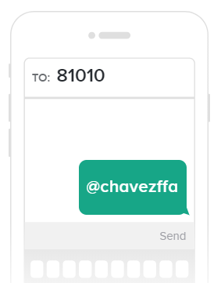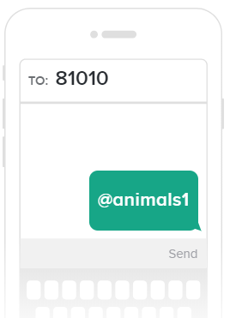
Parents and Students: Please Join Our Remind Classes to Receive Regular Updates on Chapter Activities
- Entries
- Parent Expectations
- Student Expectations:

On time each day
Stay Until Dismissal
Respond with yes and no ma’ams and sirs
Regular Show Clothes for Auction
Added check dates
- School Show Check Out- November 12th Everything cleaned out of pen

- Major Animals- $500.00- Showing at Houston Livestock Show and Rodeo
  - L/G March 7-9
- Major Animal Validation- October 29th 2018- Leaving School 2:20
- Community Service Ops- December

CHAVEZ FFA SHOW AND AUCTION: NOVEMBER 2ND AND 3RD

