Facilitators: Crumpton, Evans, Pruitt, Vayon
Please Sign In!
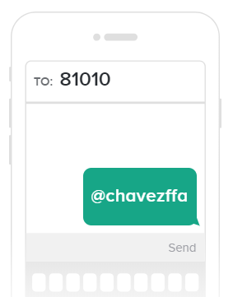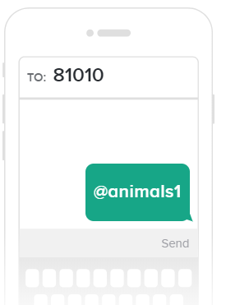
Parents and Students: Please Join Our Remind Classes to Receive Regular Updates on Chapter Activities

- Parking
  - Park Right or Leave
- Manure Piles
  - Inside the stakes
- Program Sales March 3rd
  - Buy Out or Participate- Buy Out by February Animal Meeting Feb 21
  - At the stadium gate at 2pm
  - Official Dress or FFA Flag TShirt- Only choices
- Clean Out Dates
  - March 18th- Lamb Goat
  - March 20th- Cows
- FFA State Convention
  - July 15-19 Ft Worth Texas
- Barn Work Day
  - January 31st 5 pm- Done
- T Shirt Order
  - Jan 22- Feb 1
- West Texas Trip
  - June 17-21
- Rodeo Ticket Sales

Cattle- Vayon | Rabbit- Pruitt | Lamb and Goats- Evans
Major Stock Show Money | Crosby Rabbit Show | Feb 2 Show in Anahuac
Parking
Health Paper Dates

