https://www.texasffa.org/state-convention

Above is the link where you can find information on convention. Look through it and see all the awesome things to come!

Frequently asked questions:
When are we Leaving? 8:00 am MONDAY MORNING, after loading luggage.
When are we getting there? It’s about a 3.5 hour drive plus a stop at Buccees
Where are we staying? Courtyard Fort Worth Downtown/ Blackstone
Phone numbers of Teachers: Crumpton: 254 205 3800 Evans: 972 765 7599 Pruitt: 361-437-0085

What do we bring?
  - Official Dress- multiple shirts and panty hose recommended
  - Six flags Clothes
  - Service Day Clothes
  - Toiletries like Shampoo and Tooth brush
  - Beach Towel (in case you ride water rides at Six Flags)
  - Phone and Phone charger
  - Snacks and Breakfast items- Hotel Does not have free breakfast
  - Money for Food (we encourage you to pack snacks for the long days at the convention hall but all dinners and lunches are not provided)
  - Bathing suit (the hotel will not let you swim in anything frayed on the bottom like denim shorts)
  - Regular Clothes for dinners and traveling
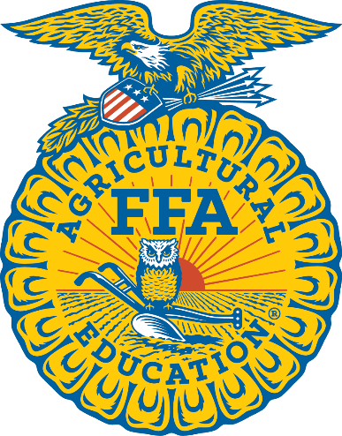
Optional Things to Bring
- Money for Shopping
- Selfie Stick
- Snack box
- Waterproof Speaker
- Floatie
- Board games
- Game console
- Teddy Bear
- Pillow
- Blanket

PLEASE IF YOU OR YOUR PARENTS HAVE ANY QUESTIONS DO NOT HESISTATE TO CALL MRS. EVANS RIGHT AWAY.
We want you all to go on and come back from this trip extremely excited for the new year!

